QRET GUI User guide & documentation

June 23, 2016

Queen’s Rocket Engineering Team

Kingston, ON

Contents

1.0 Introduction 2

2.0 Graphical Overview 3

3.0 Using the Program 5

4.0 Code Overview 5

# 1.0 Introduction

# 2.0 Graphical Overview

Figure 1 labels important features in the GUI, and Table 1 describes the function of these features.

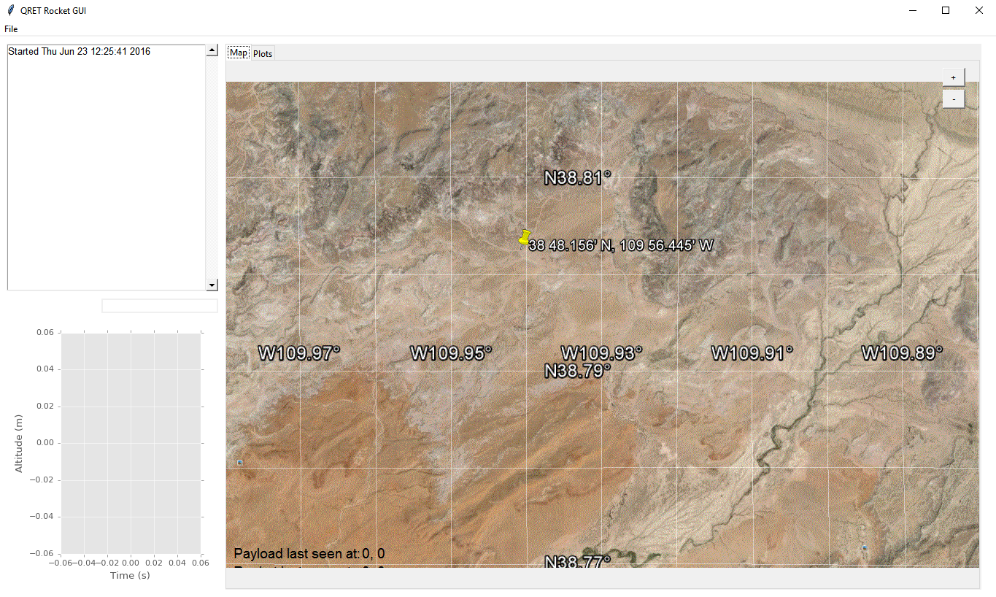

**B**

**A**

**F**

**C**

**H**

**E**

**D**

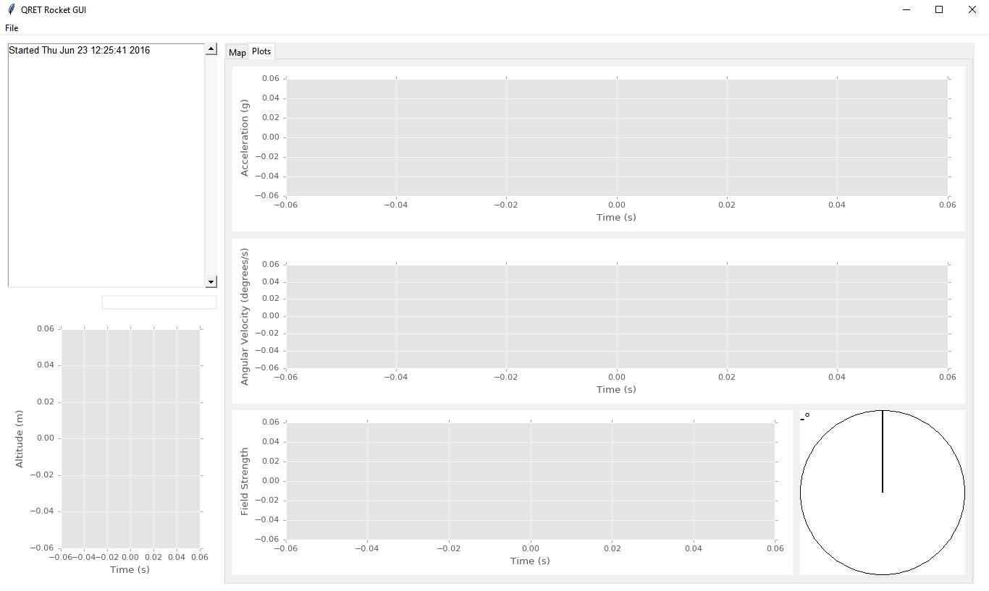

**I**

**K**

**J**

**L**

**M**

**N**

**G**

Figure : Screen captures of the GUI with labels. This is what the GUI looks like after first opening, before connecting to payload or rocket.

Table : Label legend, describing the object, its purpose, and its behaviour.

|  |  |  |
| --- | --- | --- |
| Label | Name | Description |
| A | File Menu | Contains three menu options:   * Open: currently does nothing * Export: currently does nothing * Reset data: erases all graphs and maps. Useful for clearing data collected while sitting on launch pad |
| B | Main Window | Main window that contains the application. Can be resized by dragging corners, and maximized, minimized, and closed like a regular application. |
| C | Tab Selector | Allows switching between Map and Plot tabs. Plots in the Plot tab will show the most 20 seconds of data. |
| D | +/- Buttons | Zooms the map in and out. Only useful for maps that are much larger than the screen by default |
| E | Aerial Map | Displays a satellite image of the surrounding area with coordinates overlaid. When connected to rocket and/or BRB900, their position will be plotted on the map in purple and red, respectively. |
| F | Message Window | Displays important messages, events, and warnings, such as rocket and payload connection, deployments, and data loss errors. |
| G | Altitude Plot | Plots altitude of rocket and BRB900 in blue and red, respectively. Rocket altitude is offset by the starting altitude, while the BRB900 is the absolute altitude above sea level. |
| H | Recovery Coordinates | Displays coordinates that the BRB900 and rocket (currently hidden) were last seen at. Helpful for recovery. |
| I | Acceleration Plot | Displays triaxial accelerometer readings from rocket. Current units are G. |
| J | Temperature Indicator | Displays temperature of the board, measured by the barometer. Units are °C. |
| K | Battery Indicator | Displays charge of BRB900 battery. Currently not well calibrated and so not very useful. |
| L | Gyroscope Plot | Displays triaxial gyroscope readings from rocket. Current units are °/s. |
| M | Magnetometer Plot | Displays triaxial magnetometer readings from rocket. |
| N | Tilt Indicator | Displays rocket’s tilt from vertical, as calculated by the IMU. Range is 0-180°. |

# 3.0 Using the Program

1. Plug in the receivers for the rocket and BRB900. Note which COM ports they use (can be seen in the Device Manager), and then change the default ports in serialmonitor.py to reflect the correct ports. There is functionality for automatically scanning through ports, but some issues arose and so this function has been disabled.
2. Double click on QRET_GUI.py or QRET_GUI.bat. the only difference is that running the batch file will keep the CMD window open after the program closes, which is helpful for debugging errors.
3. Turn on the rocket and BRB900. Two messages should appear stating both successfully connected. Data from the rocket should start coming in and plotted immediately.
4. Wait for the two GPS units to get a lock. Once each unit finishes this their last seen location will change from “0,0” to whatever their actual coordinates are.
5. Clear the data just before launch using File🡪Reset Data in order to hide useless data collected on the launch pad.
6. All incoming data is logged in a text file under the Logs folder. A new file is created every time the program is run.
7. If the program freezes, the best course of action is usually to close and restart it.

# 4.0 Code Overview